MongoDB Queries

use('Products');

db.createCollection("products");

// inserting datas

db.products.insertMany([

    {

        "product_name": "Smartphone",

        "brand": "BrandX",

        "price": 599.99,

        "stock_quantity": 100,

        "category": ["Electronics", "Mobile"],

        "attributes": {"color": "Black", "storage": "128GB", "RAM": "8GB"},

        "reviews": [

            {"user_id": ObjectId("987654321098765432109876"), "rating": 4, "comment": "Great phone!"},

            {"user_id": ObjectId("567890123456789012345678"), "rating": 5, "comment": "Best phone I've ever had!"}

        ]

    },

    {

        "product_name": "Laptop",

        "brand": "BrandY",

        "price": 899.99,

        "stock_quantity": 50,

        "category": ["Electronics", "Computers"],

        "attributes": {"color": "Silver", "storage": "256GB", "RAM": "16GB"},

        "reviews": [

            {"user_id": ObjectId("123456789012345678901234"), "rating": 5, "comment": "Amazing performance!"}

        ]

    },

    {

        "product_name": "Tablet",

        "brand": "BrandZ",

        "price": 299.99,

        "stock_quantity": 200,

        "category": ["Electronics", "Mobile"],

        "attributes": {"color": "White", "storage": "64GB", "RAM": "4GB"},

        "reviews": [

            {"user_id": ObjectId("234567890123456789012345"), "rating": 4, "comment": "Very handy device."}

        ]

    },

    {

        "product_name": "Smartwatch",

        "brand": "BrandX",

        "price": 199.99,

        "stock_quantity": 300,

        "category": ["Electronics", "Wearable"],

        "attributes": {"color": "Black", "storage": "32GB", "RAM": "1GB"},

        "reviews": [

            {"user_id": ObjectId("345678901234567890123456"), "rating": 3, "comment": "Good, but could be better."}

        ]

    },

    {

        "product_name": "Headphones",

        "brand": "BrandA",

        "price": 149.99,

        "stock_quantity": 150,

        "category": ["Electronics", "Audio"],

        "attributes": {"color": "Black", "storage": "N/A", "RAM": "N/A"},

        "reviews": [

            {"user_id": ObjectId("456789012345678901234567"), "rating": 4, "comment": "Excellent sound quality."}

        ]

    },

    {

        "product_name": "Camera",

        "brand": "BrandB",

        "price": 450.00,

        "stock_quantity": 30,

        "category": ["Electronics", "Photography"],

        "attributes": {"color": "Black", "storage": "N/A", "RAM": "N/A"},

        "reviews": [

            {"user_id": ObjectId("567890123456789012345678"), "rating": 5, "comment": "Crystal clear pictures!"}

        ]

    },

    {

        "product_name": "Gaming Console",

        "brand": "BrandC",

        "price": 499.99,

        "stock_quantity": 80,

        "category": ["Electronics", "Gaming"],

        "attributes": {"color": "Black", "storage": "1TB", "RAM": "8GB"},

        "reviews": [

            {"user_id": ObjectId("678901234567890123456789"), "rating": 5, "comment": "Best gaming experience ever!"}

        ]

    },

    {

        "product_name": "Television",

        "brand": "BrandD",

        "price": 799.99,

        "stock_quantity": 25,

        "category": ["Electronics", "Home Entertainment"],

        "attributes": {"color": "Black", "storage": "N/A", "RAM": "N/A"},

        "reviews": [

            {"user_id": ObjectId("789012345678901234567890"), "rating": 4, "comment": "Great picture quality!"}

        ]

    },

    {

        "product_name": "Bluetooth Speaker",

        "brand": "BrandE",

        "price": 99.99,

        "stock_quantity": 200,

        "category": ["Electronics", "Audio"],

        "attributes": {"color": "Blue", "storage": "N/A", "RAM": "N/A"},

        "reviews": [

            {"user_id": ObjectId("890123456789012345678901"), "rating": 4, "comment": "Very portable and good sound."}

        ]

    },

    {

        "product_name": "Digital Camera",

        "brand": "BrandF",

        "price": 1200.00,

        "stock_quantity": 5,

        "category": ["Electronics", "Photography"],

        "attributes": {"color": "Red", "storage": "N/A", "RAM": "N/A"},

        "reviews": [

            {"user_id": ObjectId("901234567890123456789012"), "rating": 5, "comment": "Professional-grade camera."}

        ]

    }

]);

// Retrieve all products in the "Electronics" category

db.products.find({ category: "Electronics" });

// Find all products with a price less than $500.

db.products.find({ price: { $lt: 500 } });

// Retrieve all products with a rating greater than 4.

db.products.find({ "reviews.rating": { $gt: 4 } });

//  Retrieve all products sorted by price in descending order.

db.products.find().sort({ price: -1 });

//  Calculate the average rating of all products.

db.products.aggregate([

    { $unwind: "$reviews" },

    { $group: { _id: null, avgRating: { $avg: "$reviews.rating" } } }

]);

//  Find all products where the stock quantity is less than 10.

db.products.find({ stock_quantity: { $lt: 10 } });

//  Retrieve all products with a specific brand (e.g., BrandX).

db.products.find({ brand: "BrandX" });

//  Find all products where the storage is 128GB and RAM is 8GB.

db.products.find({ "attributes.storage": "128GB", "attributes.RAM": "8GB" });

//  Retrieve all products with a specific user's review (e.g., user_id: ObjectId("987654321098765432109876")).

db.products.find({ "reviews.user_id": ObjectId("987654321098765432109876") });

//  Calculate the total number of reviews for each product.

db.products.aggregate([

    { $project: { product_name: 1, totalReviews: { $size: "$reviews" } } }

]);

//  Find all products with a price between $400 and $600.

db.products.find({ price: { $gte: 400, $lte: 600 } });

//  Find all products with a specific category (e.g., "Mobile") and a stock quantity greater than 50.

db.products.find({ category: "Mobile", stock_quantity: { $gt: 50 } });

//  Find the highest rated product.

db.products.aggregate([

    { $unwind: "$reviews" },

    { $group: { _id: "$_id", product_name: { $first: "$product_name" }, maxRating: { $max: "$reviews.rating" } } },

    { $sort: { maxRating: -1 } },

    { $limit: 1 }

]);

//  Retrieve all products sorted by brand in ascending order and then by price in descending order.

db.products.find().sort({ brand: 1, price: -1 });

//  Find all products with a specific comment in their reviews (e.g., "Great phone!").

db.products.find({ "reviews.comment": "Great phone!" });

## Table Data - Answers

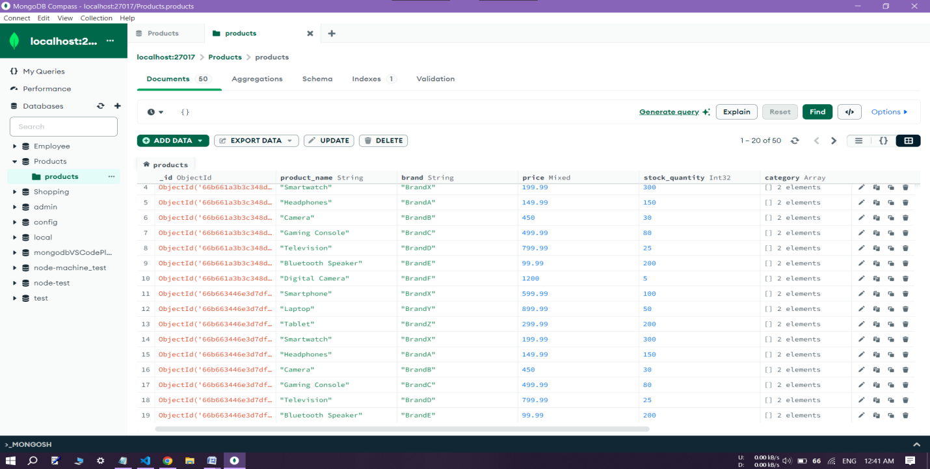

[

  {

    "_id": {

      "$oid": "66b65b4e691a1799b9b83bb7"

    },

    "product_name": "Smartphone",

    "brand": "BrandX",

    "price": 599.99,

    "stock_quantity": 100,

    "category": [

      "Electronics",

      "Mobile"

    ],

    "attributes": {

      "color": "Black",

      "storage": "128GB",

      "RAM": "8GB"

    },

    "reviews": [

      {

        "user_id": {

          "$oid": "987654321098765432109876"

        },

        "rating": 4,

        "comment": "Great phone!"

      },

      {

        "user_id": {

          "$oid": "567890123456789012345678"

        },

        "rating": 5,

        "comment": "Best phone I've ever had!"

      }

    ]

  },

  {

    "_id": {

      "$oid": "66b65b4e691a1799b9b83bb8"

    },

    "product_name": "Laptop",

    "brand": "BrandY",

    "price": 899.99,

    "stock_quantity": 50,

    "category": [

      "Electronics",

      "Computers"

    ],

    "attributes": {

      "color": "Silver",

      "storage": "256GB",

      "RAM": "16GB"

    },

    "reviews": [

      {

        "user_id": {

          "$oid": "123456789012345678901234"

        },

        "rating": 5,

        "comment": "Amazing performance!"

      }

    ]

  },

  {

    "_id": {

      "$oid": "66b65b4e691a1799b9b83bb9"

    },

    "product_name": "Tablet",

    "brand": "BrandZ",

    "price": 299.99,

    "stock_quantity": 200,

    "category": [

      "Electronics",

      "Mobile"

    ],

    "attributes": {

      "color": "White",

      "storage": "64GB",

      "RAM": "4GB"

    },

    "reviews": [

      {

        "user_id": {

          "$oid": "234567890123456789012345"

        },

        "rating": 4,

        "comment": "Very handy device."

      }

    ]

  },

  {

    "_id": {

      "$oid": "66b65b4e691a1799b9b83bba"

    },

    "product_name": "Smartwatch",

    "brand": "BrandX",

    "price": 199.99,

    "stock_quantity": 300,

    "category": [

      "Electronics",

      "Wearable"

    ],

    "attributes": {

      "color": "Black",

      "storage": "32GB",

      "RAM": "1GB"

    },

    "reviews": [

      {

        "user_id": {

          "$oid": "345678901234567890123456"

        },

        "rating": 3,

        "comment": "Good, but could be better."

      }

    ]

  },

  {

    "_id": {

      "$oid": "66b65b4e691a1799b9b83bbb"

    },

    "product_name": "Headphones",

    "brand": "BrandA",

    "price": 149.99,

    "stock_quantity": 150,

    "category": [

      "Electronics",

      "Audio"

    ],

    "attributes": {

      "color": "Black",

      "storage": "N/A",

      "RAM": "N/A"

    },

    "reviews": [

      {

        "user_id": {

          "$oid": "456789012345678901234567"

        },

        "rating": 4,

        "comment": "Excellent sound quality."

      }

    ]

  },

  {

    "_id": {

      "$oid": "66b65b4e691a1799b9b83bbc"

    },

    "product_name": "Camera",

    "brand": "BrandB",

    "price": 450,

    "stock_quantity": 30,

    "category": [

      "Electronics",

      "Photography"

    ],

    "attributes": {

      "color": "Black",

      "storage": "N/A",

      "RAM": "N/A"

    },

    "reviews": [

      {

        "user_id": {

          "$oid": "567890123456789012345678"

        },

        "rating": 5,

        "comment": "Crystal clear pictures!"

      }

    ]

  },

  {

    "_id": {

      "$oid": "66b65b4e691a1799b9b83bbd"

    },

    "product_name": "Gaming Console",

    "brand": "BrandC",

    "price": 499.99,

    "stock_quantity": 80,

    "category": [

      "Electronics",

      "Gaming"

    ],

    "attributes": {

      "color": "Black",

      "storage": "1TB",

      "RAM": "8GB"

    },

    "reviews": [

      {

        "user_id": {

          "$oid": "678901234567890123456789"

        },

        "rating": 5,

        "comment": "Best gaming experience ever!"

      }

    ]

  },

  {

    "_id": {

      "$oid": "66b65b4e691a1799b9b83bbe"

    },

    "product_name": "Television",

    "brand": "BrandD",

    "price": 799.99,

    "stock_quantity": 25,

    "category": [

      "Electronics",

      "Home Entertainment"

    ],

    "attributes": {

      "color": "Black",

      "storage": "N/A",

      "RAM": "N/A"

    },

    "reviews": [

      {

        "user_id": {

          "$oid": "789012345678901234567890"

        },

        "rating": 4,

        "comment": "Great picture quality!"

      }

    ]

  },

  {

    "_id": {

      "$oid": "66b65b4e691a1799b9b83bbf"

    },

    "product_name": "Bluetooth Speaker",

    "brand": "BrandE",

    "price": 99.99,

    "stock_quantity": 200,

    "category": [

      "Electronics",

      "Audio"

    ],

    "attributes": {

      "color": "Blue",

      "storage": "N/A",

      "RAM": "N/A"

    },

    "reviews": [

      {

        "user_id": {

          "$oid": "890123456789012345678901"

        },

        "rating": 4,

        "comment": "Very portable and good sound."

      }

    ]

  },

  {

    "_id": {

      "$oid": "66b65b4e691a1799b9b83bc0"

    },

    "product_name": "Digital Camera",

    "brand": "BrandF",

    "price": 1200,

    "stock_quantity": 5,

    "category": [

      "Electronics",

      "Photography"

    ],

    "attributes": {

      "color": "Red",

      "storage": "N/A",

      "RAM": "N/A"

    },

    "reviews": [

      {

        "user_id": {

          "$oid": "901234567890123456789012"

        },

        "rating": 5,

        "comment": "Professional-grade camera."

      }

    ]

  }

]

[

  {

    "_id": {

      "$oid": "66b65b4e691a1799b9b83bba"

    },

    "product_name": "Smartwatch",

    "brand": "BrandX",

    "price": 199.99,

    "stock_quantity": 300,

    "category": [

      "Electronics",

      "Wearable"

    ],

    "attributes": {

      "color": "Black",

      "storage": "32GB",

      "RAM": "1GB"

    },

    "reviews": [

      {

        "user_id": {

          "$oid": "345678901234567890123456"

        },

        "rating": 3,

        "comment": "Good, but could be better."

      }

    ]

  }

]

[

  {

    "_id": null,

    "avgRating": 4.363636363636363

  }

]

[

  {

    "_id": {

      "$oid": "66b65b4e691a1799b9b83bb7"

    },

    "product_name": "Smartphone",

    "brand": "BrandX",

    "price": 599.99,

    "stock_quantity": 100,

    "category": [

      "Electronics",

      "Mobile"

    ],

    "attributes": {

      "color": "Black",

      "storage": "128GB",

      "RAM": "8GB"

    },

    "reviews": [

      {

        "user_id": {

          "$oid": "987654321098765432109876"

        },

        "rating": 4,

        "comment": "Great phone!"

      },

      {

        "user_id": {

          "$oid": "567890123456789012345678"

        },

        "rating": 5,

        "comment": "Best phone I've ever had!"

      }

    ]

  }

]